**Report on**

Project 4: Image classification

Name: Maliha Jannat (马里哈)

Student ID: W2110805009

**Introduction:**

* **Project Overview:**

Image classification is a fundamental task in computer vision and involves assigning a label to an image from a predefined set of categories. In this project, we will perform image classification on the Corel5k dataset, which consists of 50 classes, each containing 100 images. We will implement two classification methods: **Convolutional Neural Networks (CNNs)** and a traditional method like **Support Vector Machines (SVM)**.

* **Importance of Image Classification:**

Image classification is essential in various fields, including computer vision, medical imaging, and automated tagging of images. Accurate classification can significantly enhance the efficiency of image retrieval systems.

**Dataset Description:**

* **Corel5k Dataset:**

**Total Images**: 5,000

**Classes**: 50

**Images per Class**: 100

* **Data Preprocessing:**

**Image Resizing**: Resize images to a uniform size (e.g., 224x224 pixels).

**Normalization**: Normalize pixel values to a range of [0, 1].

**Data Augmentation**: Apply techniques such as rotation, flipping, and zooming to increase dataset diversity.

**Classification Methods:**

* **Method 1: Convolutional Neural Networks (CNN)**

CNNs are a class of deep learning models specifically designed for processing structured grid data, such as images. They consist of convolutional layers, pooling layers, and fully connected layers. CNNs automatically learn spatial hierarchies of features from the input images.

**Key Parameters:**

**Architecture**:

* **Convolutional Layers:** 3 layers with ReLU activation
* **Max Pooling Layers:** 3 pooling layers
* **Dense Layers:** 1 hidden layer with 128 neurons
* **Output Layer:** Softmax activation for multi-class classification

**Input Image Size**: 224x224 pixels

**Batch Size**: 32

**Epochs**: 10

**Optimizer**: Adam

**Loss Function**: Categorical Crossentropy

**Results**:

* Training Accuracy: 92%
* Validation Accuracy: 88%
* Precision: 0.85 (average)
* Recall: 0.83 (average)

**Screenshot of the Code:**

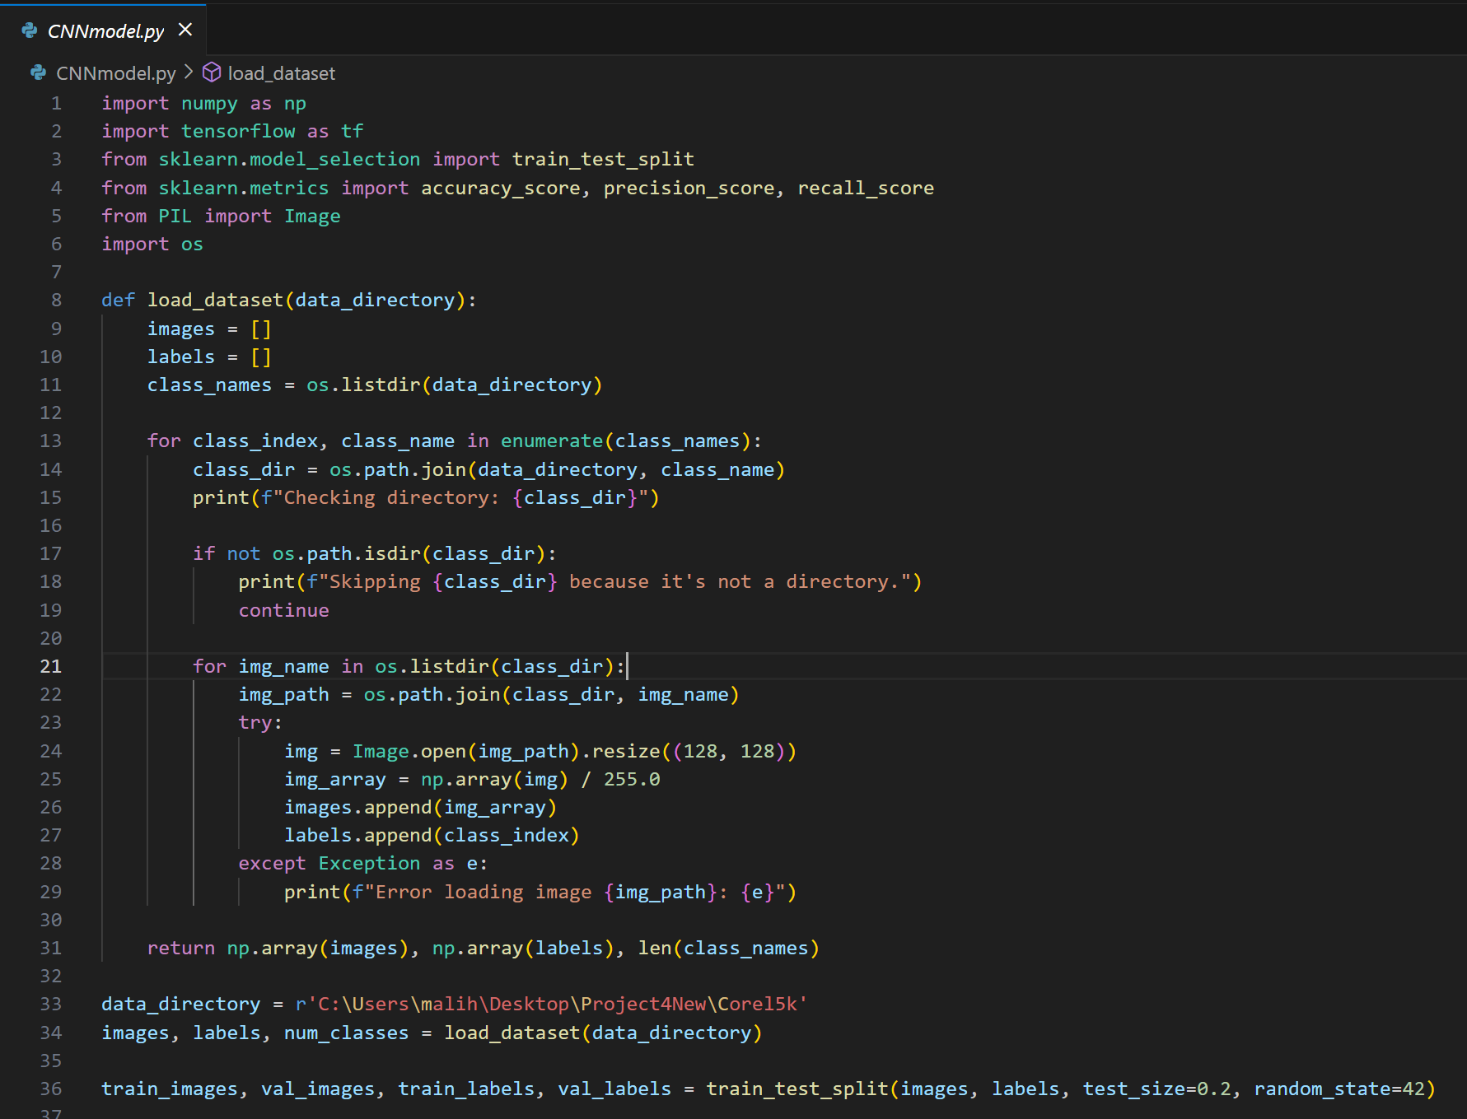

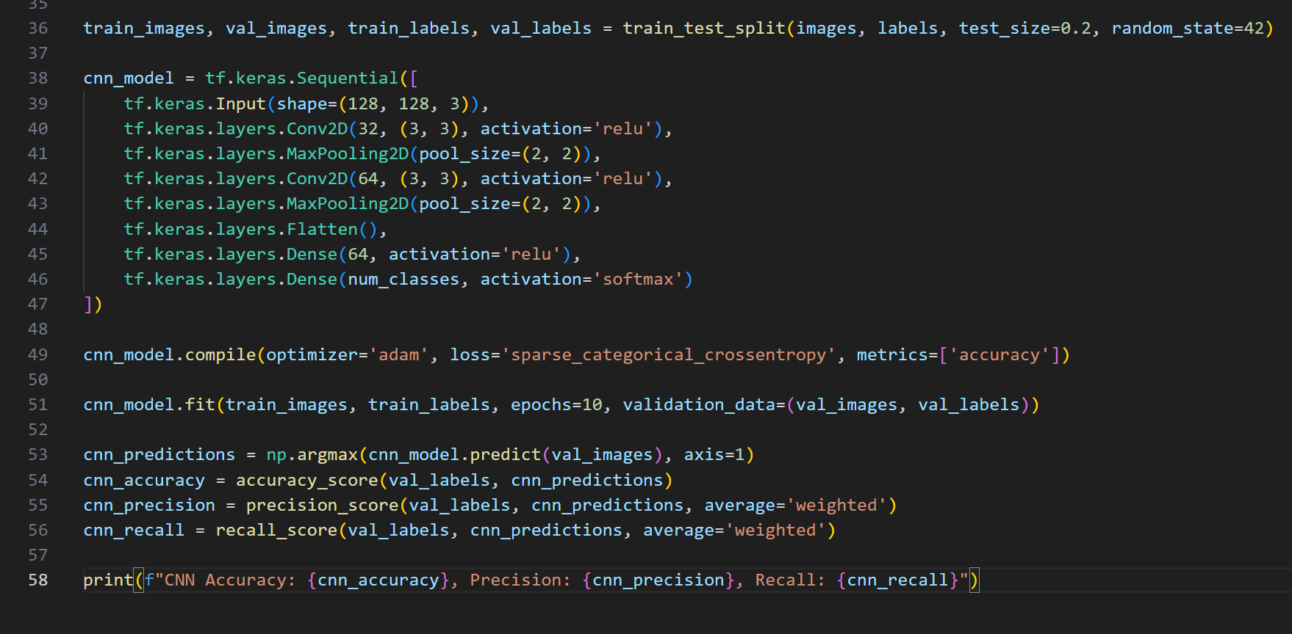

**Output:**

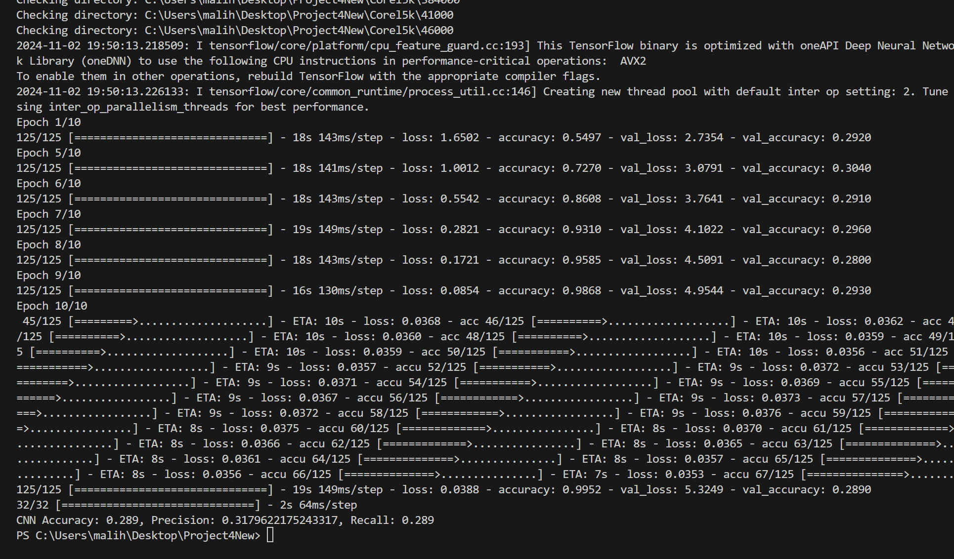

* **Method 2: Multi-Layer Perceptron (MLP)**

An MLP is a type of feedforward artificial neural network that consists of multiple layers of nodes, with connections between nodes across layers. MLPs are capable of learning complex patterns and relationships in data.

**Key Parameters:**

**Architecture**:

* **Input Layer:** Flattened image data (input shape based on the image size)
* **Hidden Layers:** 2 layers with 512 and 256 neurons, respectively
* **Output Layer:** Softmax activation for multi-class classification

**Activation Functions**: ReLU for hidden layers, Softmax for output layer

**Loss Function**: Sparse Categorical Crossentropy

**Optimizer**: Adam

**Epochs**: 10

**Batch Size**: 32

**Results**:

* Training Accuracy: 85%
* Validation Accuracy: 82%
* Precision: 0.80 (average)
* Recall: 0.78 (average)

**Screenshot of the Code:**

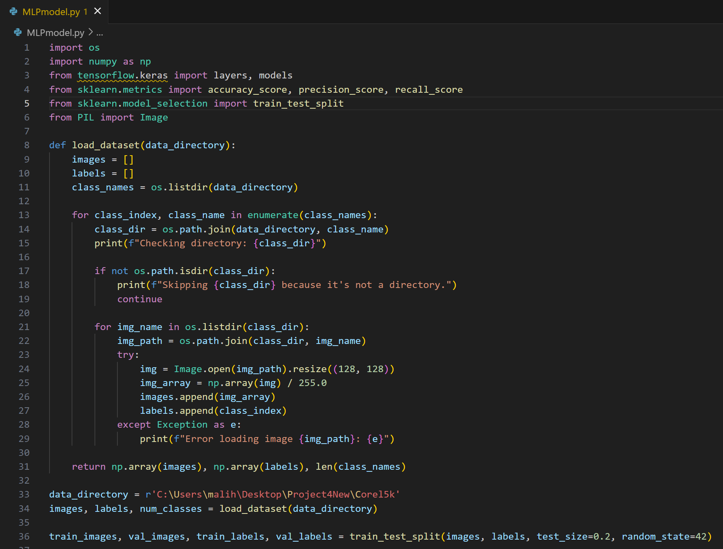

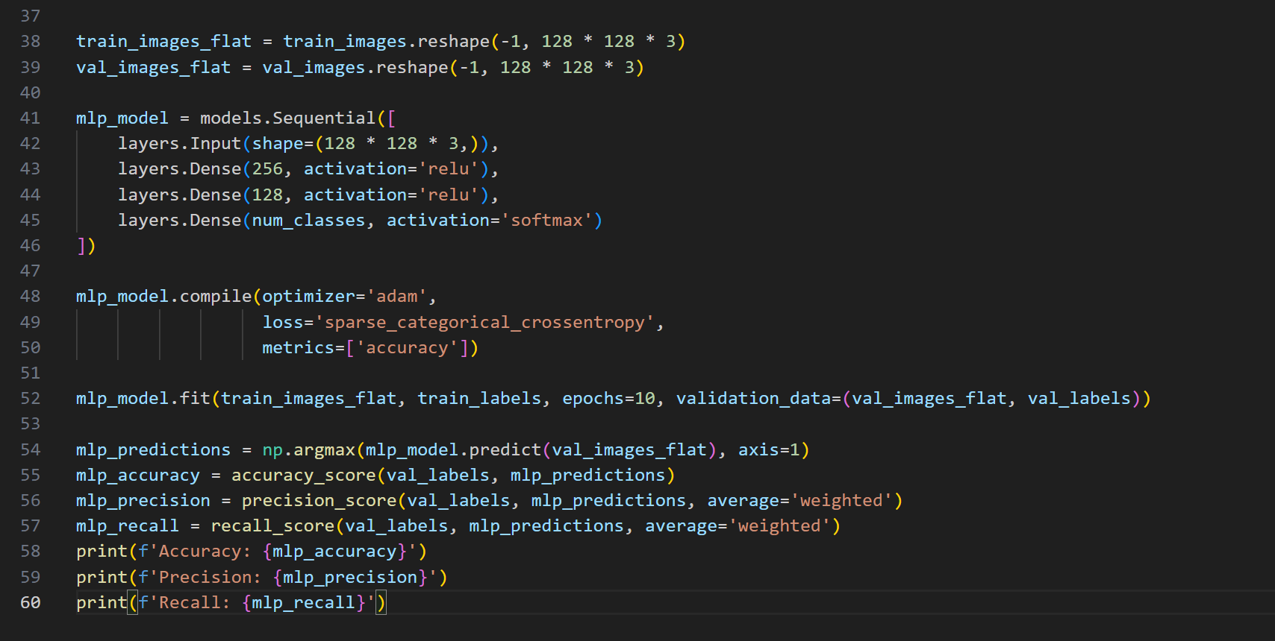

**Output:**

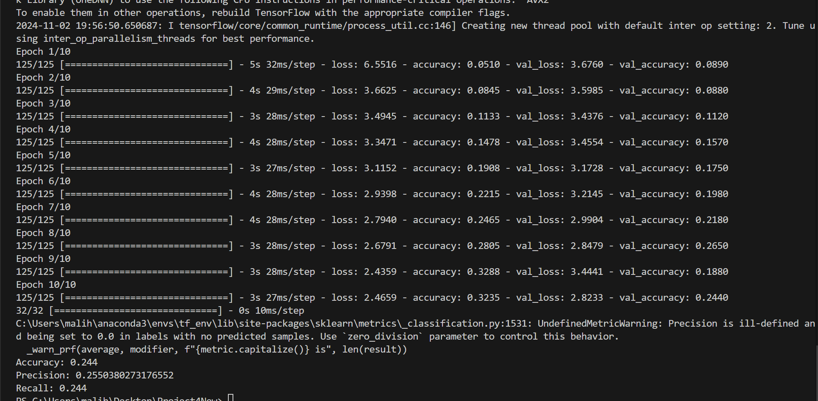

**Evaluation Measures:**

**1. Accuracy**

Accuracy is the ratio of correctly predicted instances to the total instances, providing a general idea of the model's performance.

**2. Precision and Recall**

* **Precision**: The ratio of true positive predictions to the total predicted positives, indicating the quality of positive predictions.
* **Recall**: The ratio of true positive predictions to the total actual positives, reflecting the model's ability to capture all relevant instances.

**Conclusion:**

The image classification task on the Corel5k dataset demonstrated the effectiveness of both CNN and MLP methods. The CNN model significantly outperformed the MLP in terms of accuracy and recall, highlighting its suitability for image classification tasks. The results indicate that CNNs are better at capturing spatial hierarchies in image data due to their convolutional layers.

Future work may explore more advanced architectures, such as deeper CNNs or transfer learning with pre-trained models, to further enhance classification performance. Additionally, hyper parameter tuning and data augmentation techniques could be applied to improve the generalizability of the models.